**Health Service System Dashboard for Inpatient and Outpatient Waiting List Analysis (2018–2021)**

**1. Assumptions**

1. The data is sourced from the hospital's **patient management system (PMS)** or **electronic health record (EHR)**.
2. The waiting list includes both **in-patient (IPD) and out-patient (OPD) cases**.
3. Data is **updated regularly** (daily, weekly, or monthly) to ensure accurate tracking. A breakdown by **specialty, department, and Age limit** is included.
4. The analysis covers both **current status** and **historical trends**.
5. **Stakeholder Engagement**: Assumes active participation from all relevant stakeholders in the dashboard's development and implementation.

**2. Problems/Challenges Faced**

* **Data Quality and Completeness**: Inconsistent or incomplete data can hinder accurate analysis. Detailed Analysis on Basis of prime criteria like age group, speciality level not available.
* **System Integration**: Challenges in integrating the dashboard with existing hospital information systems may arise. Many years of data are not combined.
* **User Adoption**: Ensuring that healthcare professionals effectively use the dashboard can be challenging.
* **Data Security and Privacy**: Protecting patient data in compliance with regulations is crucial.
* **Resource Constraints**: Limited financial and human resources may affect the dashboard's development and maintenance.

**3. Discussion Points with Stakeholders**

* **Data Sources and Accuracy**: Discuss the reliability and completeness of data sources.
* **Integration Capabilities**: Evaluate the dashboard's compatibility with existing systems.
* **User Training**: Plan for training healthcare professionals to use the dashboard effectively.
* **Privacy and Security Measures**: Ensure compliance with data protection regulations.
* **Resource Allocation**: Determine the budget and personnel required for development and maintenance.

**Overall Objective**

1. Track current status of patient waiting list
2. Analyse historical monthly trend of waiting list in Inpatient & Outpatient categories
3. Detailed specialty level & age profile analysis

**Data Scope**

2018 – 2021

**Data Model used**

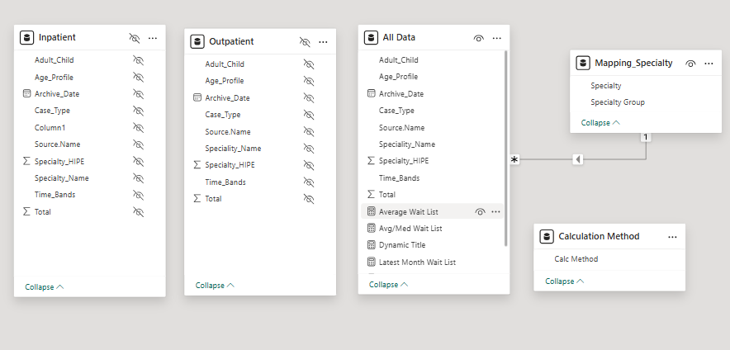

**Visualization Blueprint**

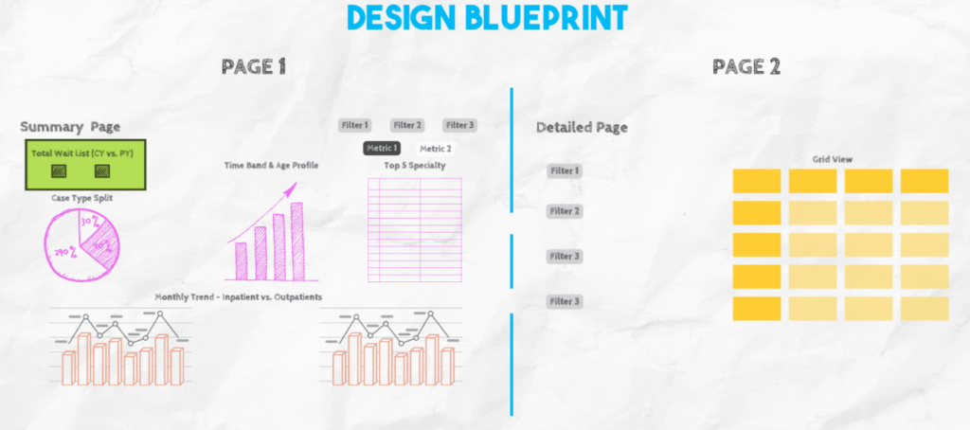

**Metrics**

1. Average & Median Waiting List
2. Current Total Wait List

**DAX Calculations**

Using DAX to create our measures, we will create 2 measures for calculating Latest Month & Previous Year Wait List

Latest Month Wait List = CALCULATE(SUM(All_Data[Total]),All_Data[Archive_Date] = MAX(All_Data[Archive_Date])) + 0

PY Latest Month Wait List = CALCULATE(SUM(All_Data[Total]),All_Data[Archive_Date]= EDATE(MAX(All_Data[Archive_Date]),-12)) + 0

Now as per our design blueprint, these 2 measures can be inserted in a card visual.

After this, we will create a blank table where we will store calculation method headers, i.e. in our dashboard we want to show Average values and Median values.

To make few charts titles dynamic, we can create this:

Median Wait List = MEDIAN(All_Data[Total])

Average Wait List = AVERAGE(All_Data[Total])

Avg/Med Wait List = SWITCH(VALUES('Calculation Method'[Calc Method]),"Average",[Average Wait List],"Median",[Median Wait List])

Dynamic Title = SWITCH(VALUES('Calculation Method'[Calc Method]),"Average","Key Indicators - Patient Wait List (Average)","Median","Key Indicators - Patient Wait List (Median)")

**View**

1. Summary Page

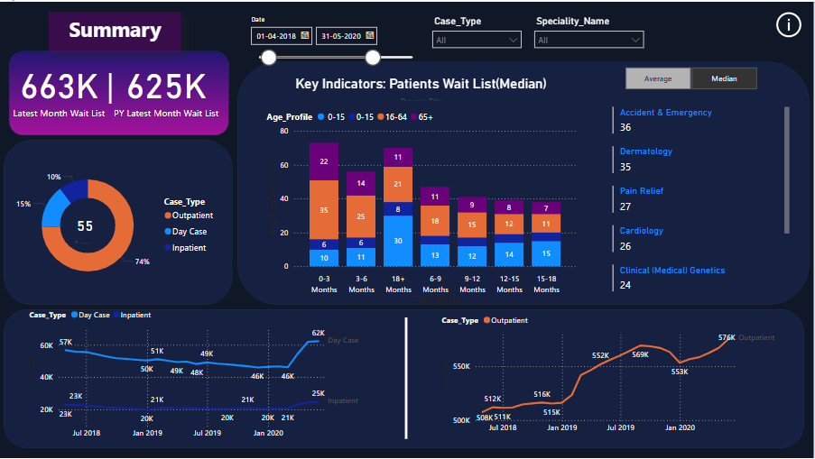

1. Detailed Page for Granular Analysis

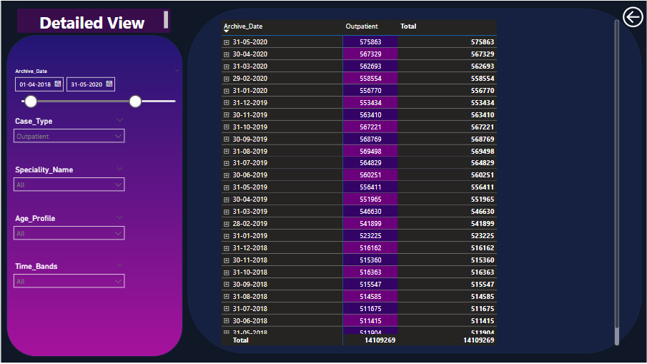

Thank You.

Sayantani Dey.